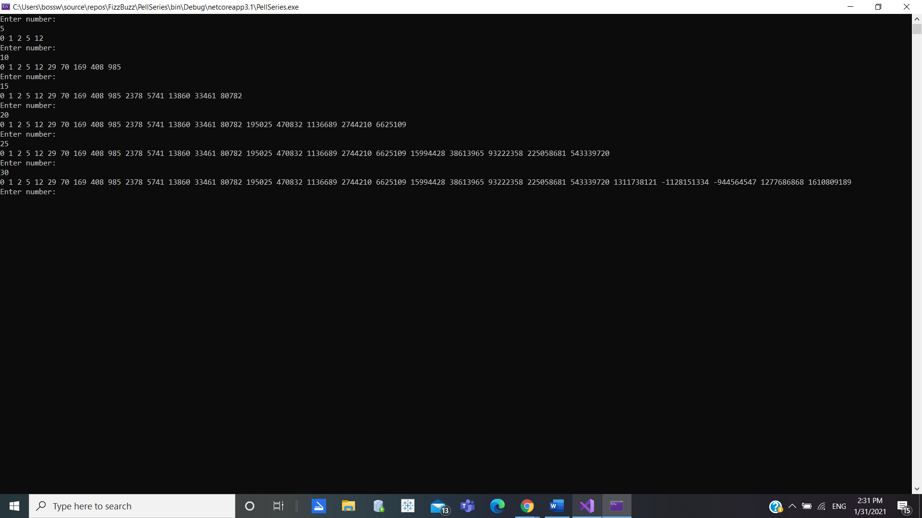

Screen Shot for Pell Numbers